**Smart Parking using IOT SYSTEM**

**TEAM MEMBER**

**Name : HEMANATHAN S**

**NM id : au411521106019**

**Phase-2 Document Submission**

## Project : Smart Parking

## IoT based smart parking system

**OBJECTIVE:**

The project involves integrating IoT sensors into public transportation vehicles to monitor ridership, track locations, and predict arrival times. The goal is to provide real-time transit information to the public through a public platform, enhancing the efficiency and quality of public transportation services.

**Introduction to Smart Parking :**

Smart parking refers to the use of advanced technologies and innovative solutions to optimize the process of finding, reserving, and paying for parking spaces. As urban areas continue to grow, the demand for parking spaces has increased significantly, leading to traffic congestion, environmental pollution, and overall inefficiency in urban transportation systems. Smart parking systems aim to address these challenges by leveraging various technologies to make parking easier, faster, and more convenient for both drivers and parking facility operators.

**Key Components of Smart Parking:**

1. **Sensors and IoT Devices:** Smart parking systems use sensors and IoT (Internet of Things) devices to detect the occupancy status of parking spaces in real-time. These sensors can be embedded in the ground, attached to streetlights, or installed on walls and send data to a central server.
2. **Mobile Applications:** Smart parking apps allow users to find and reserve parking spaces using their smartphones. These apps provide real-time information about available parking spots, pricing, and navigation to the chosen location.
3. **Automated Payment Systems:** Smart parking solutions often include automated payment systems that enable users to pay for parking electronically, reducing the need for physical payment methods and enhancing the overall user experience.
4. **Integration with Navigation Systems:** Smart parking systems can be integrated with GPS and navigation applications to provide drivers with real-time directions to the nearest available parking spaces, reducing the time spent searching for parking.

**Need for smart parking:**

**Solution: Smart Parking using IOT SYSTEM**

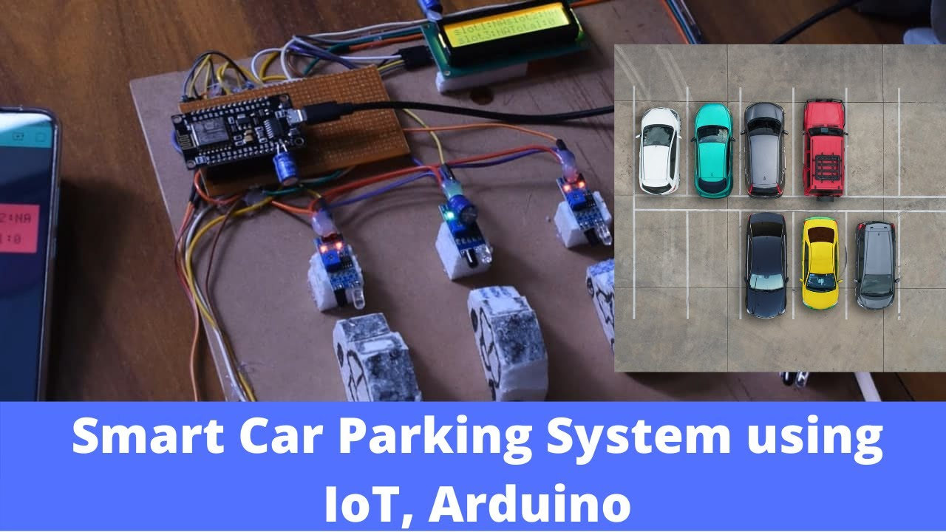

In summary, smart parking systems utilize technology to transform the parking experience, making it more convenient for drivers while also addressing urban congestion and environmental concerns. By leveraging real-time data and innovative solutions, smart parking contributes to creating smarter, more efficient cities.

**Block diagram :**

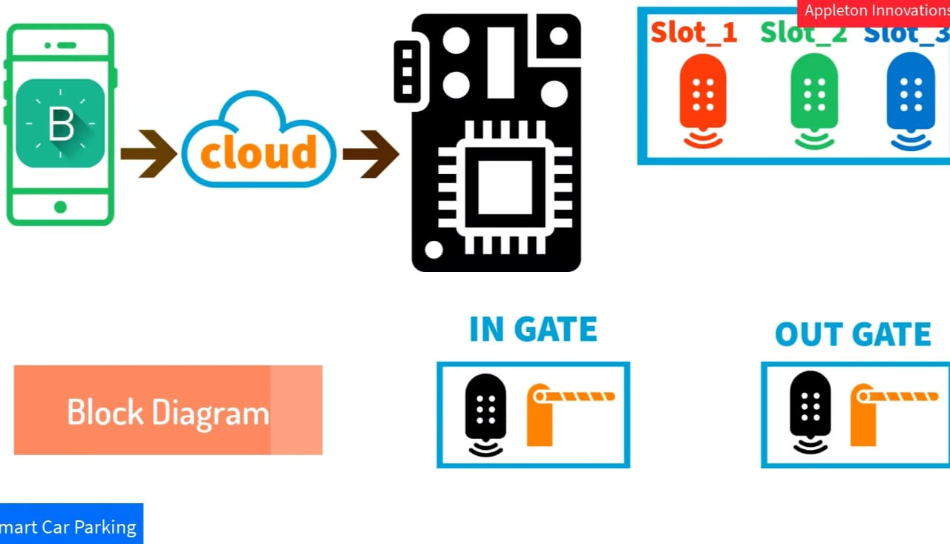

**Hardware requirements:**

**Software requirements:**

**Arduino 1.8.1**

**Program :**

#define BLYNK_PRINT Serial

#include <ESP8266WiFi.h>

#include <BlynkSimpleEsp8266.h>

#include <Servo.h>

Servo servo;

Servo servo1;

char auth[] = "NvvkkwRRSxhj8LPECPSY35qRgBK1UCEN";

char ssid[] = "APPLETON";

char pass[] = "Gladys@123";

const int gateInIR = D2;

const int gateOutIR = D1;

const int slotoneIR = D4;

const int slotTwoIR = D5;

const int slotThreeIR = D3;

int total = 0;

int IR1 = 1;

int IR2 = 1;

int IR3 = 1;

BlynkTimer timer:

WidgetLCD lcd (V1);

void setup() {

Serial.begin(9600) I

Blynk.begin (auth, ssid, pass);

pinMode (gateInIR, INPUT);

pinMode (gateOutIR, INPUT);

pinMode(slotoneIR, INPUT);

pinMode (slotTwoIR, INPUT);

pinMode(slotThreeIR, INPUT);

servo.attach (D7);

servol.attach (D8);

timer.setInterval (10000L, carParking);

**Conclusion:**

By integrating these modules, the Smart Parking system using IoT offers a comprehensive solution to address the challenges of urban parking, leading to improved efficiency, reduced environmental impact, and enhanced user satisfaction.

**FUTURE WORK:**

